‘Best Kept Secret’ Visit Summary

Friday, April 20, 2012
Consol Energy Center
Host: Kim Wood, Matthew Haynes
Guests: Rob Wilson, Lynna Martinez, Urban Pathways Charter School students

Organized by Rob Wilson of Blazer Capital, ‘The Best Kept Secret’ is a program that exposes Pittsburgh inner city students to professional opportunities that they might not otherwise be aware of. Young people today are inundated by images of fame and fortune particularly in the form of athletes and entertainers. It is important for students to understand that there are many different avenues to success, including ones they may not have previously considered.
The link below displays ‘The Best Kept Secret’ introductory YouTube video that Rob has produced. The video further explains the intent behind the program.
Approximately 25 students from Urban Pathways Charter School along with Lynna Martinez, the Supervisor of College Readiness, visited the Consol Energy Center on Friday. They heard remarks from Rob Wilson and Kim Wood in the Cal U Conference Room. Rob reiterated the message of ‘The Best Kept Secret’ and the YouTube video (which features some of those same students) was shown. Kim discussed her path to her current position with the Pittsburgh Penguins. She also stressed the importance of education, networking, involvement in the community and being open to unconventional opportunities:
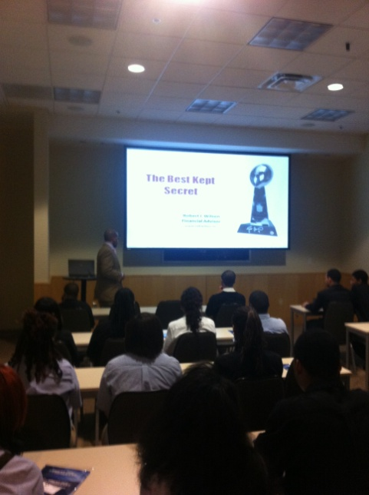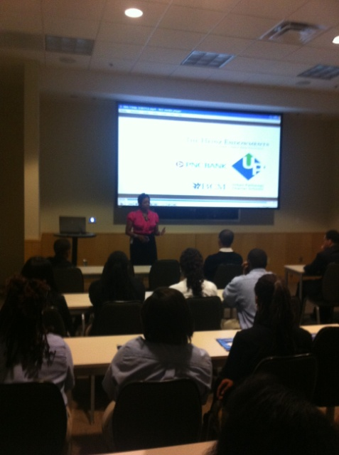
After Kim and Rob’s remarks, the students were taken on a tour of Consol Energy Center. The first stop was the Jim Beam suite where the students stopped briefly to take pictures of the arena:
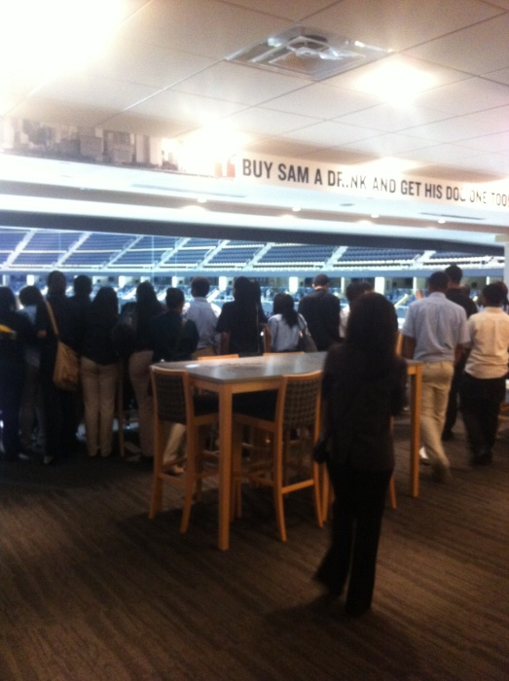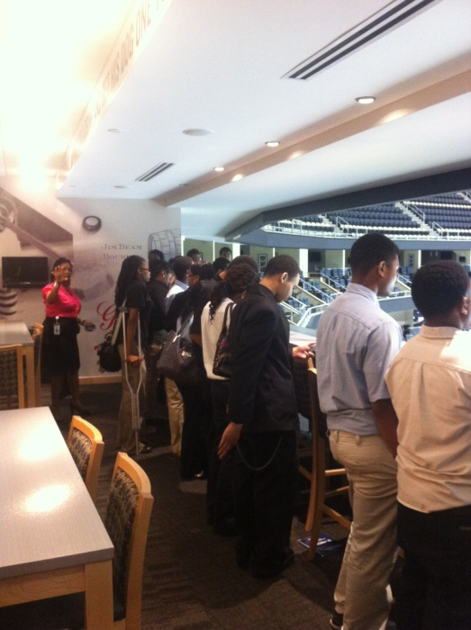

The next stop was the Lexus Club where the students could get a full view of the Lower Hill redevelopment site and the remains of the Civic Arena. After the Lexus club, the guests were able to use the interactive screens at the Trib Total Media Gate:
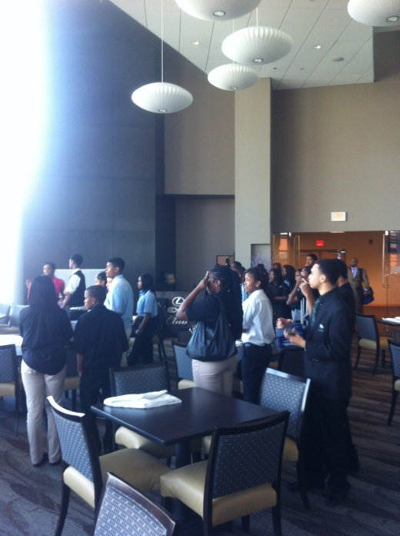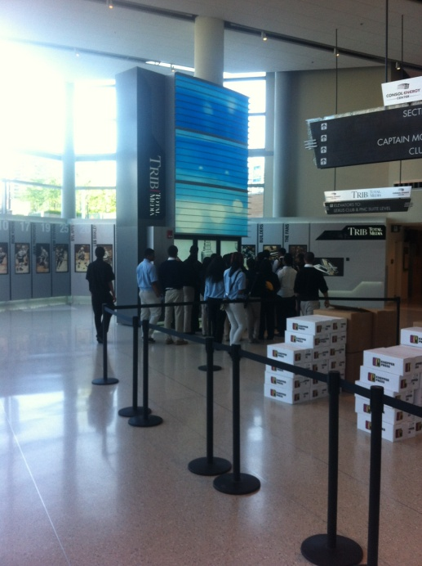

The final stop was the American Eagle gate for a group picture:
